# Bruce Branch (KACT)

# Remote Steering - Program Loading

# A group of items on a table Description automatically generatedStock exchange numbers

# Remote Steering Equipment Types

2 Tiller Sensors (one shown)

2 Tiller Control Boxes

2 Square Handsets 2 Key Fob Handsets 2 “T” Handsets

1 Box Handset (not shown)

# Remote Steering Program Loading Instructions

Contents

1. Tiller Units
2. “T” Handsets
3. Box Handset
4. Square Handset
5. Key Fob Handset
6. Tiller Units
   1. These have Arduino Nano’s, with a short USB cable attached
   2. Attach USB to PC
   3. Use Arduino Tiller Programme: BoatTillerEndTxNRF24_Infin_OLEDopt_SupTxAccelChanDelayNoTX.ino

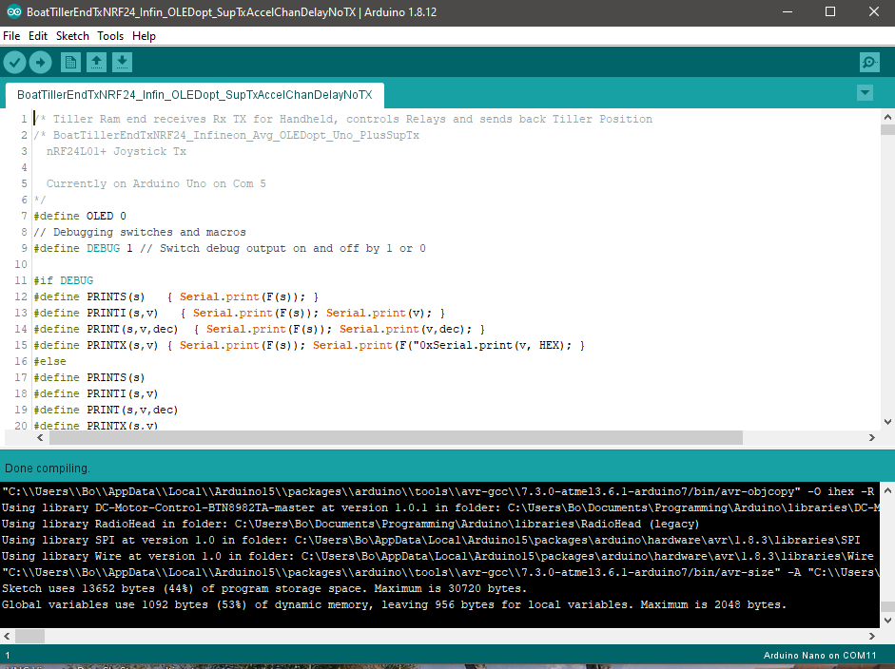

* 1. Tool Settings:
     1. Board: “Arduino Nano”
     2. Processor: “ATmega328P (Old Bootloader)
     3. Port “COMXX” (whatever port the USB is on eg XX)
     4. Programmer: “ArduinoISP”
     5. Upload the programme

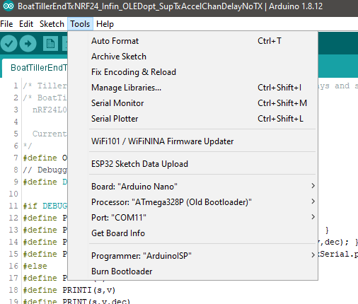

1. “T” Handsets
   1. These have Arduino Uno Chips with Tx/RX DTR Serial programming
   2. They use FDI Programmers attached to the PC USB
   3. Use Arduino Handset Programme: BoatContRxNRF24_Sleep_Arc4RdGnMidShipSuperChanNoTX_Mints.ino

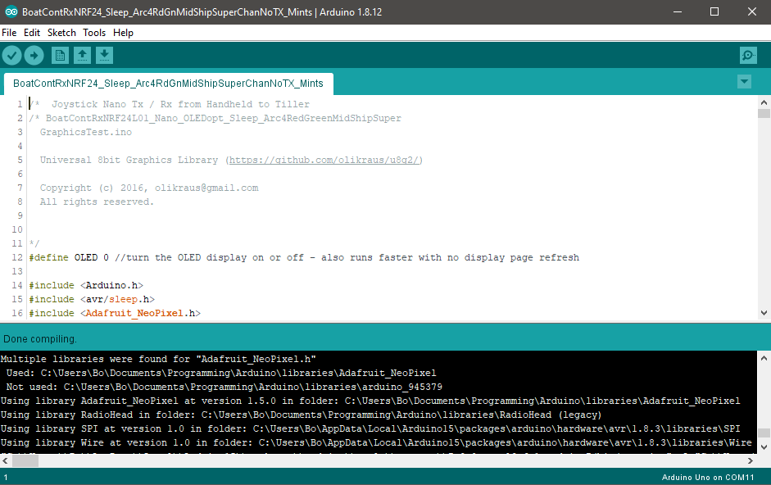

* 1. Tool Settings:
     1. Board: “Arduino Uno”
     2. Port “COMXX” (whatever port the USB is on eg XX)
     3. Programmer: “ArduinoISP”
     4. Upload the programme

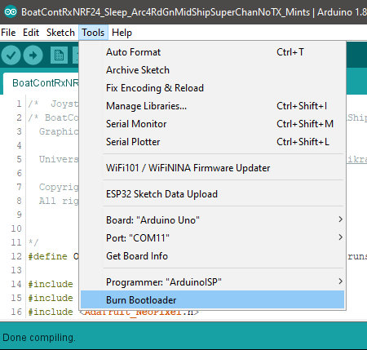

1. Box Handsets
   1. These have Arduino Uno Chips with Tx/RX DTR Serial programming
   2. They use FDI Programmers attached to the PC USB
   3. Use Arduino Handset Programme: BoatContRxNRF24_Sleep_Arc4RdGnMidShipSuperChanNoTX_Mints.ino



* 1. Tool Settings:
     1. Board: “Arduino Uno”
     2. Port “COMXX” (whatever port the USB is on eg XX)
     3. Programmer: “ArduinoISP”
     4. Upload the programme



1. Key Fob Handsets
   1. These have Arduino Uno Chips, with Tx/RX DTR Serial programming, however they are smaller and have no Crystal – running on an 8 MHz internal Clock with a different Boot-Loader.
   2. They use FDI Programmers attached to the PC USB
   3. Use Arduino Handset Programme: BoatContRxNRF24_Sleep_Arc4RdGnMidShipSuperChanNoTX_Mints.ino



* 1. Tool Settings:
     1. Board: “ATmega328 on a Breadboard (8 MHz internal clock)”
     2. Port “COMXX” (whatever port the USB is on eg XX)
     3. Programmer: “ArduinoISP”
     4. Upload the programme

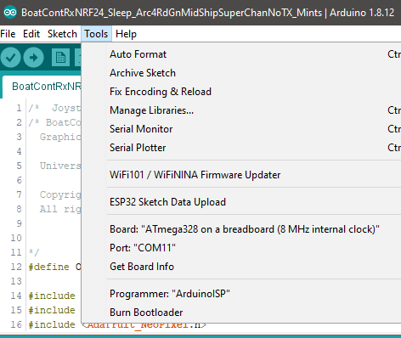

* 1. It is also possible to program the actual chip using the AVR-ISP programmer

AVR ISP Programmer

* 1. Again we load the Arduino Handset Programme: BoatContRxNRF24_Sleep_Arc4RdGnMidShipSuperChanNoTX_Mints.ino
  2. Tool Settings differ from before:
     1. Board: “ATmega328 on a Breadboard (8 MHz internal clock)”
     2. Port “COMXX” (whatever port the USB is on eg XX)
     3. Programmer: “Arduino as ISP” 🡨 Note this is different, you must use “Arduino **as** ISP”, NOT “ArduinoISP”

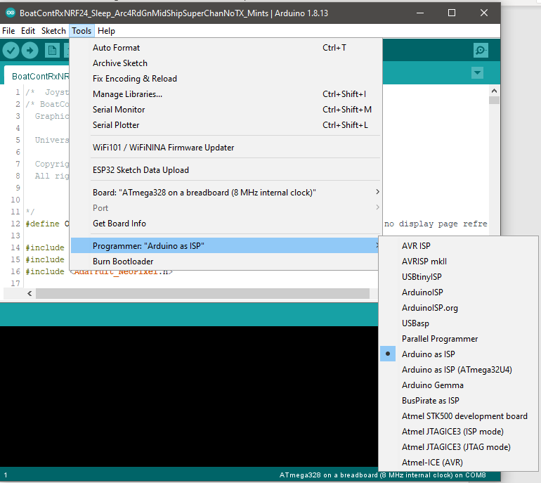

* 1. Upload the programme using “Upload Using Programmer” option in the Sketch menu

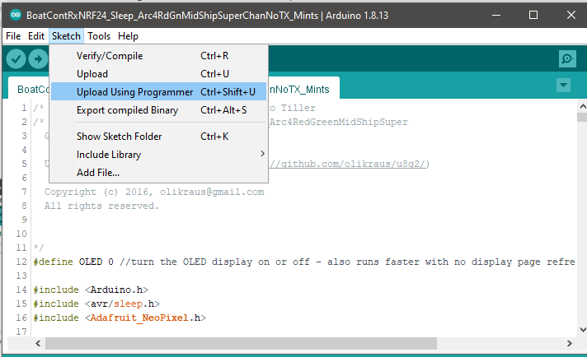

Note that this is not the standard upload as it uses “Arduino as ISP”, so the above command must be used.

The programmer will “Beep” on successful upload!

3x AA 1.5V Alkaline LR3200 3.2V Button Cell

Handset

First two Switches set to address 1

Key Fob Unit

